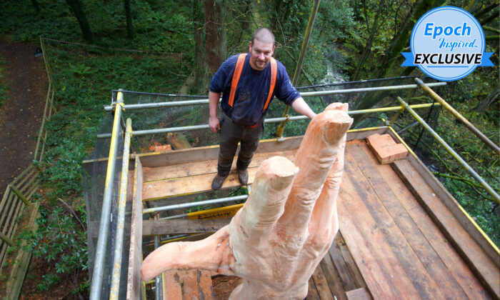
(Courtesy of Simon O'Rourke)
LIFE & TRADITION

Chainsaw Sculptor Transforms a Storm-Damaged Tree Into a 50ft Hand Instead of Cutting It
BY JENNI JULANDER

December 17, 2020 Updated: January 18, 2021
biggersmaller
Print
This story was last updated in December 2020.
When the tallest tree in Wales suffered devastating storm damage and was due to be cut down, the forest service had a different idea: to commission an artist to sculpt the tree into a memorial.
Now, the carving has been completed, and the sculptor is being hailed as a visionary for turning the once-glorious tree into the “Giant Hand of Vyrnwy,” a stunning 50-foot sculpture of a giant hand reaching for the sky, as if to reclaim its former grandeur.
The carving belongs to the forestry commission and is not for sale; however, according to the artist, a similar work of art would sell for roughly 12,000 pounds (US$16,237).
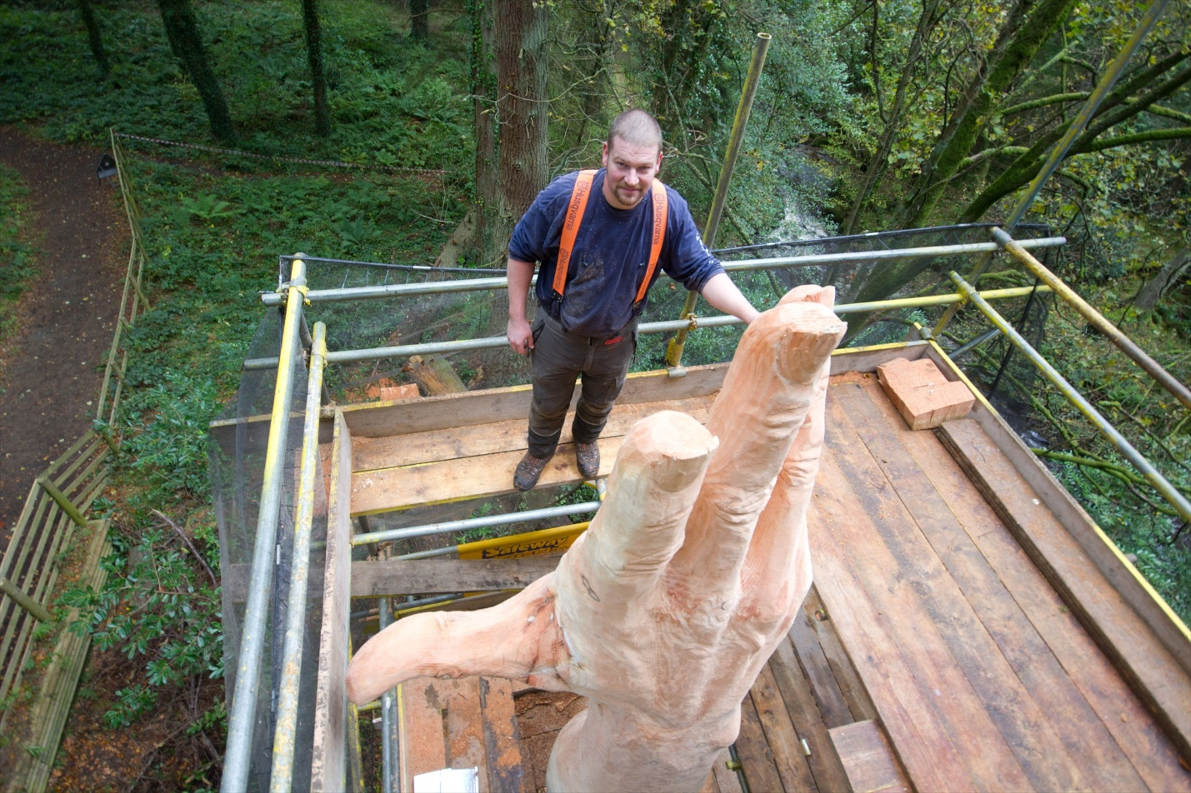(Courtesy of Simon O’Rourke)
The artist, Simon O’Rourke, is an award-winning chainsaw sculptor with several first-place awards in the English Open Chainsaw Carving Competition under his belt—not your average run-of-the-mill carpenter. He uses discarded, damaged trees to craft breathtaking works of art that complement their surroundings.
O’Rourke was saddened to hear of the demise of the tallest tree in Wales. So, when he heard that Natural Resource Wales had called for design submissions, he knew it would be an honor to work on such a project.
“I was really excited at the prospect of carving this giant hand and creating a memorial for such a well-known landmark,” O’Rourke shared on his website.
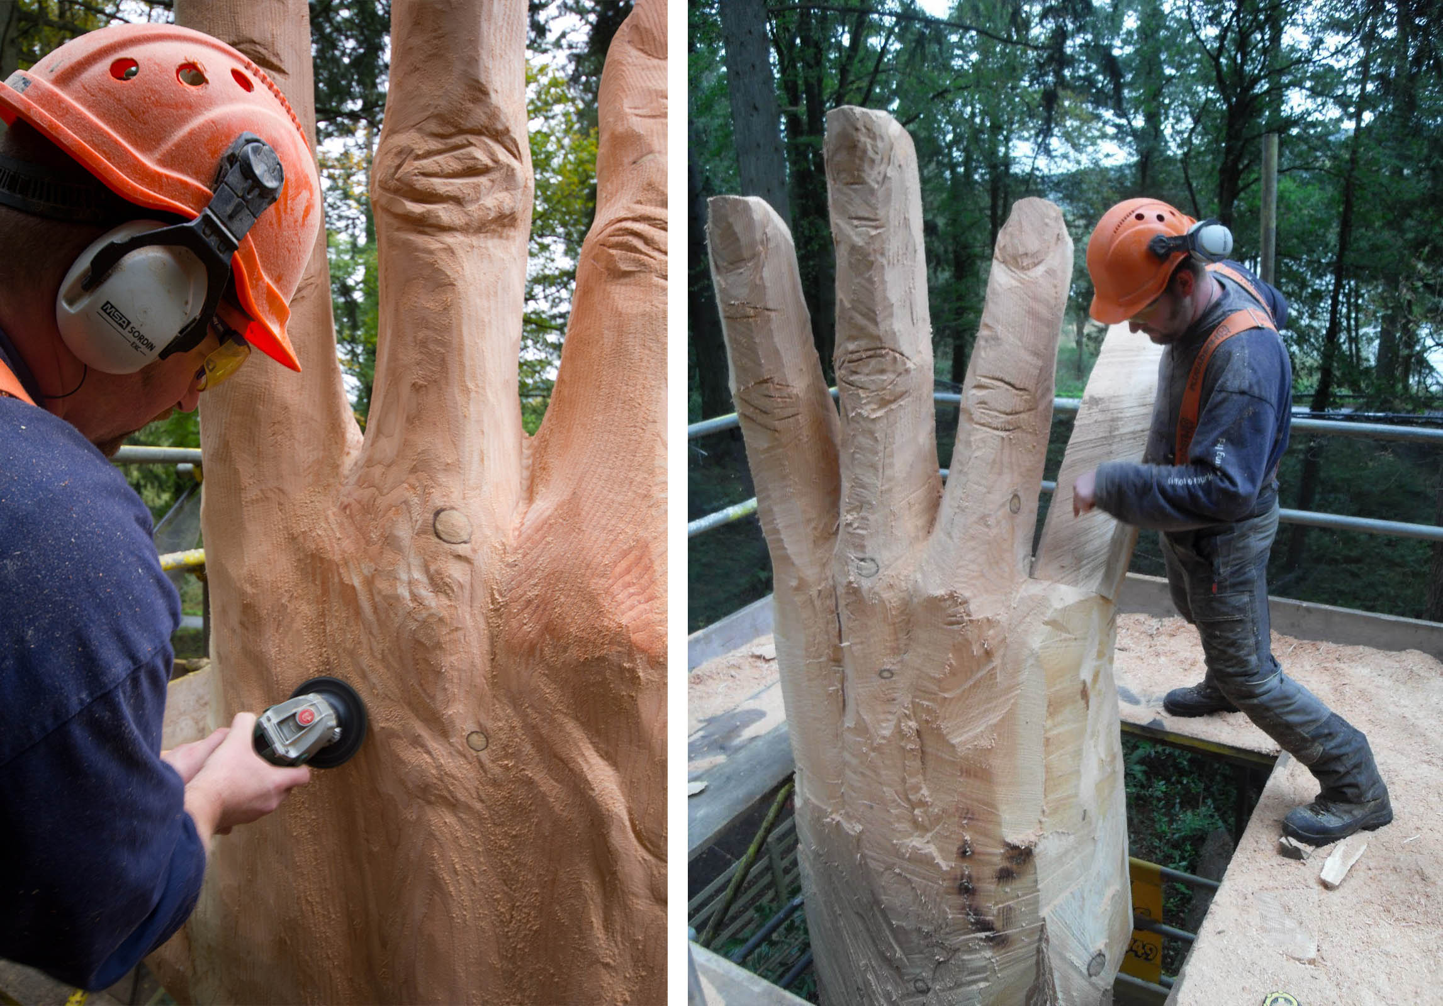(Courtesy of Simon O’Rourke)
“I began researching the area and found the area of woodland that contained the tree was known as the Giants of Vyrnwy. This got me thinking, and I decided on a giant hand, symbolizing the giants.”
O’Rourke told The Epoch Times that the symbolism was also meant to reflect the tree’s last attempt to reach the sky.
“I really felt the whole group of trees were fighting to reach the light,” he said. “To emphasize the feel of that, I wanted to connect it to something people could identify with.”
Apparently, his inspired idea caught on, for the forestry commission selected O’Rourke to carve the tree.
“It was important to do something to give the tree a purpose after its sad demise,” O’Rourke told The Epoch Times.
Armed with a chainsaw and a vision, he set out to tackle the technical aspects of the project, setting up scaffolding and planning out the exact scale and dimensions of the enormous hand.
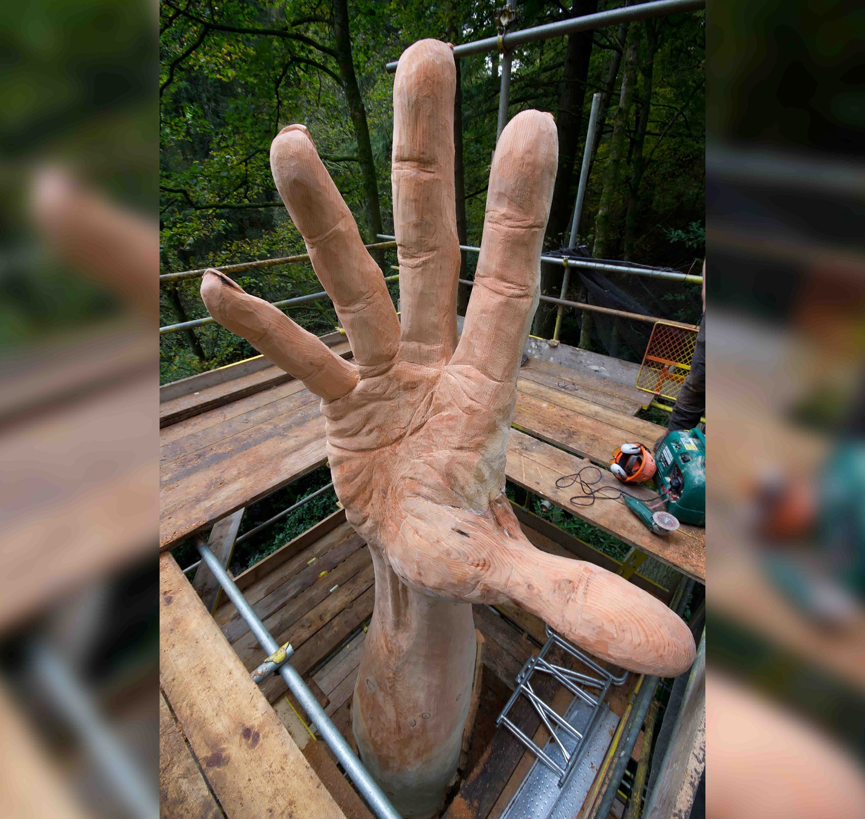(Courtesy of Simon O’Rourke)
“To work on a giant scale without being able to stand back easily was a challenge,” he said. “I love to push myself, so it was a welcome challenge, and I chose to use my own hand as a model.
“I used a scale of 1:10, and worked without a glove on my right hand so I could constantly refer to and measure it.”
The confined workspace made it difficult to accurately assess the scale, so an artist friend helped out, acting as a spotter.
“He would go a distance off and view it from various points and we would call each other to discuss it,” said the sculptor.
But that wasn’t the only difficulty to deal with.
It turns out the tree wasn’t wide enough for the whole hand, so the thumb had to be constructed separately. O’Rourke says mounting the thumb was the biggest obstacle, and at one point he thought it might actually be impossible due to its weight.
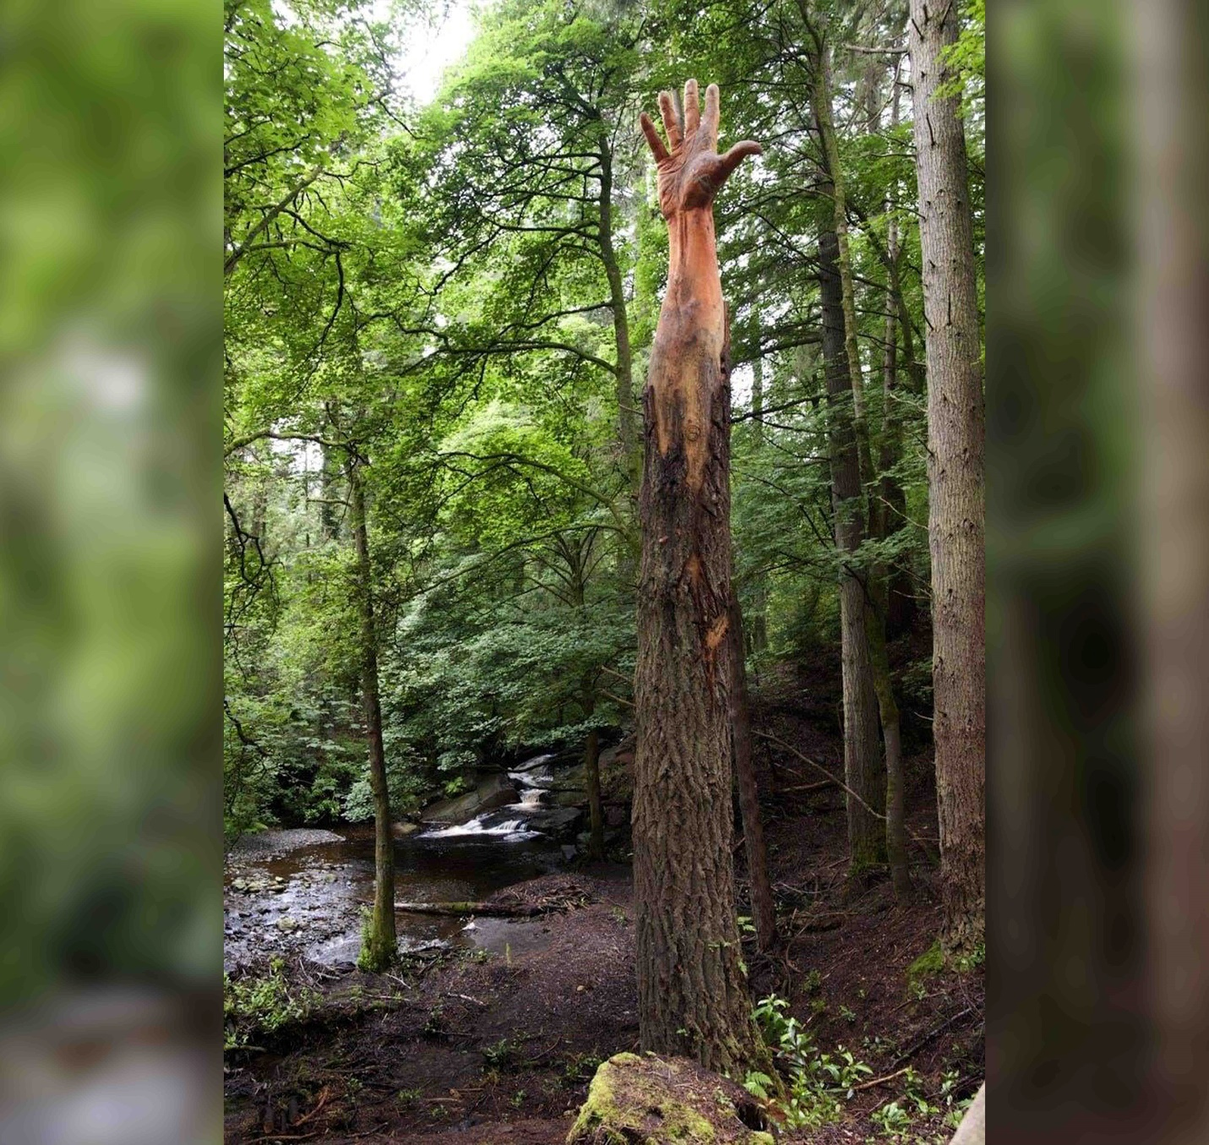(Courtesy of Simon O’Rourke)
“When I carved it to reduce the weight and went to fit it, it was clear I would need some extra pieces to fill the gaps left,” he said. “I had to scrounge around the offcuts to find enough pieces to create the right shaped wedge to fit the gap.”
But luckily, it all worked out. After getting the thumb fitted correctly, the artist coated the carving in Tung oil, a natural plant-based oil that’s safe to be used in proximity to waterways.
Six days later, O’Rourke stood back to take in his newest natural work of art.
“I was really pleased with the finished piece,” O’Rourke said. “The response from all the locals and the Forestry Commission (who had commissioned it) was fantastic.”
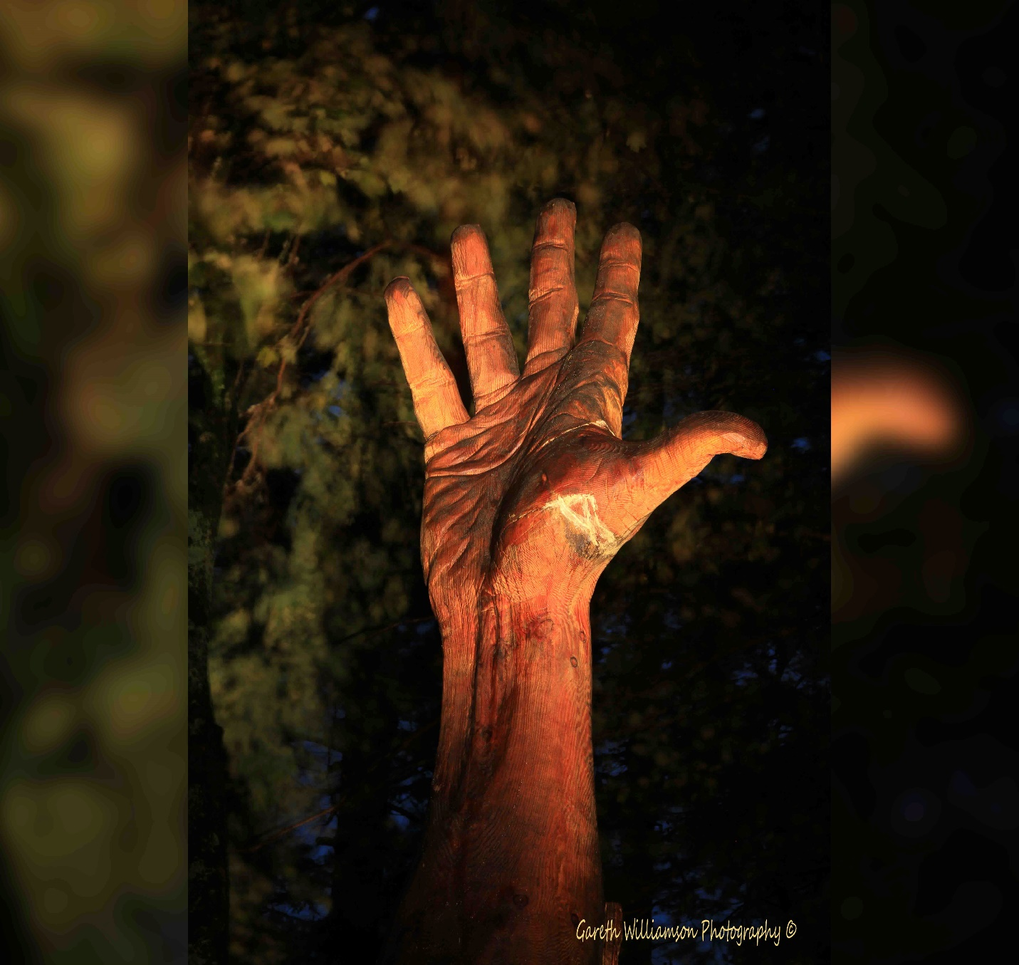(Courtesy of Gareth Williamson Photography via Simon O’Rourke)
He shared photos of the colossal carving on his Facebook page late October, and viewers responded with sheer amazement.
“A fitting tribute,” wrote one admirer.
On his website, O’Rourke wrote about the experience, emphasizing how much the project meant to him.
“I loved working on the hand sculpture,” he shared. “It reminded me just how small we are compared to some of the living organisms on this planet! All in all, a humbling experience!”
We would love to hear your stories! You can share them with us here: emg.inspired@epochtimes.com

