Prizes will be drawn from lowest monetary value to highest monetary value. The highest valued prize will be drawn last. The items below are not in any particular order.

1) Oneida Ultimate Dust Deputy For Festool - $249 - Donated by Oneida Air Systems
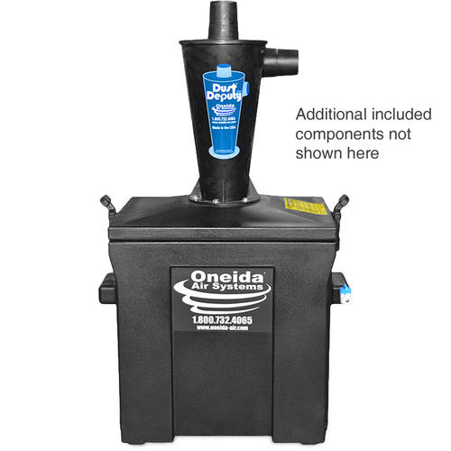
2) Super Dust Deputy - $169 - Donated by Oneida Air Systems
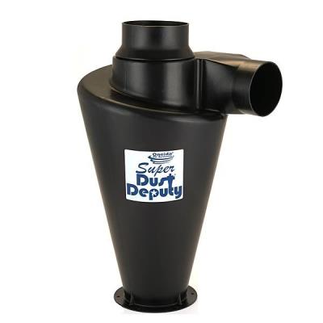
3) Dust Deputy Deluxe - $99 - Donated by Oneida Air Systems
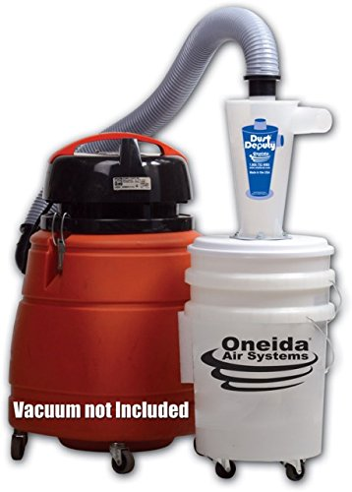
4) Viper Scraper Tool - $23.99 - Donated by Oneida Air Systems
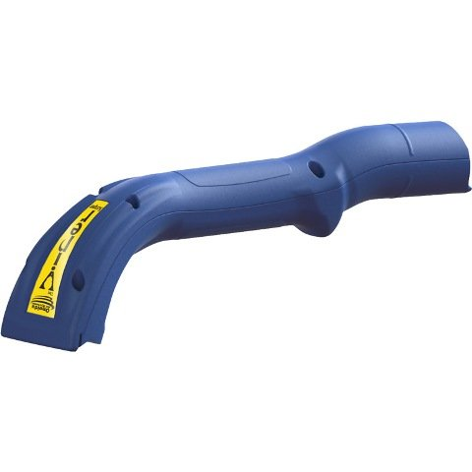
5) Fuji 2202 semi-PRO 2 HVLP Spray System - $399 - Donated by Fuji Spray
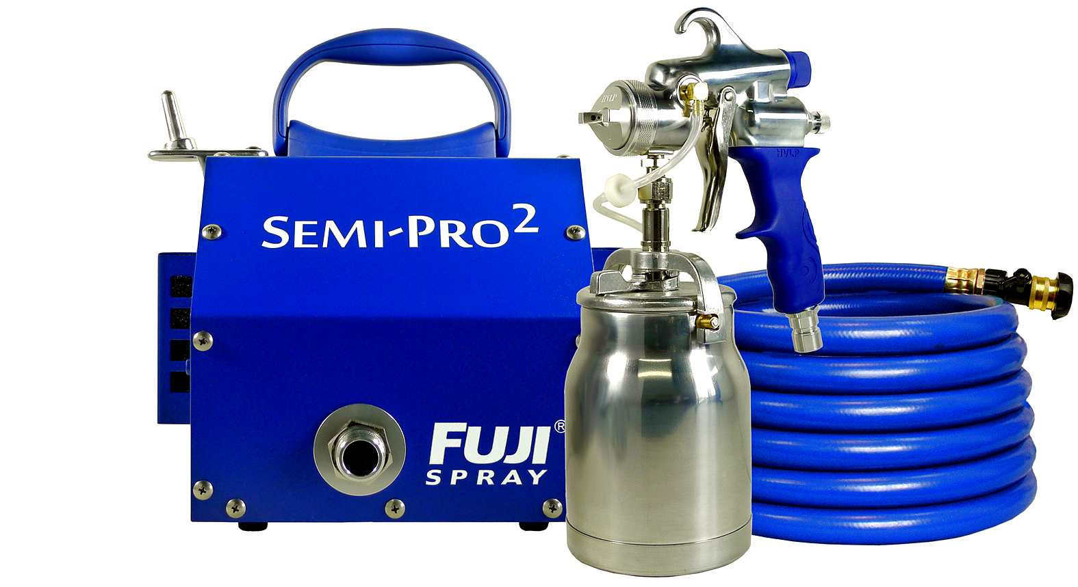

6) "The Perfect Edge" - $27 - Donated by Hock Tools
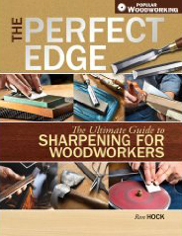
7) Pair of Gramercy Tools Holdfasts - $34.95 - Donated by Tools for Working Wood
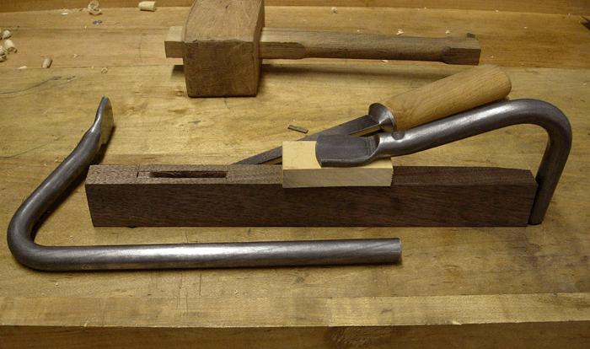
8) Lie Nielsen Small Bronze Scraper Plane - $175 - Donated by Lie-Nielsen Toolworks
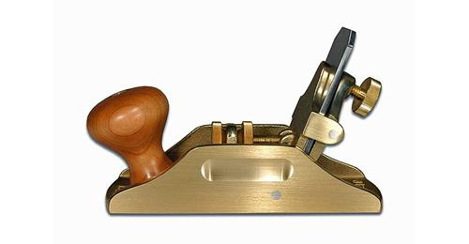
9) Easy Wood Tools Mid-Size Hollower - $129.99 - Donated by Easy Wood Tools
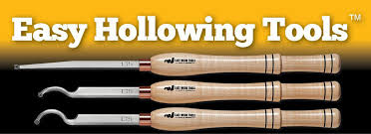
10,11,12) Qty=3 $50 Gift Certificates (3 separate prizes @ $50 each) - Donated by Lee Valley Tools
13) Woodpeckers 12" Precision Square 1281 - $99.99 - Donated by Woodpeckers
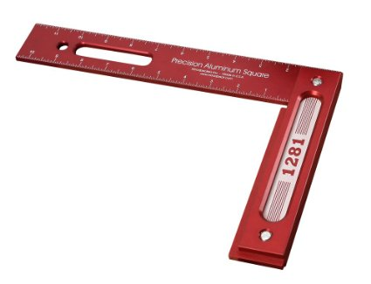

14) Woodpeckers Precision Woodworking Square Combo (6" & 8") - $129.99 - Donated by Woodpeckers
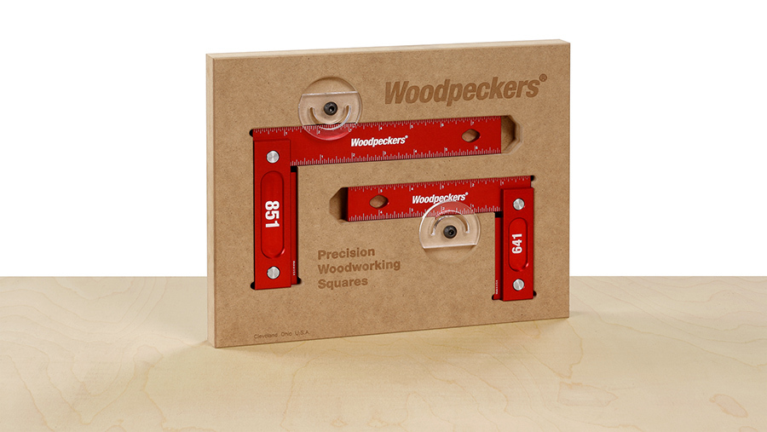

15) Woodpeckers 24" Precision Woodworking T-Square - $99.99 - Donated by Woodpeckers
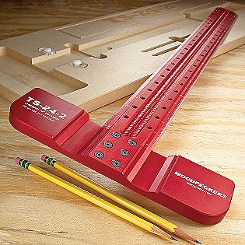

16) Stewart-MacDonald $100 Gift Certificate - Donated by Stewart-MacDonald
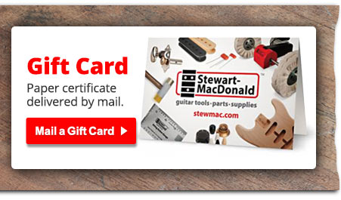
17) Pint of Seal-Lac ($20.95) & Pint of Royal-Lac ($22.95) - $43.90 - Donated by Shellac Finishes
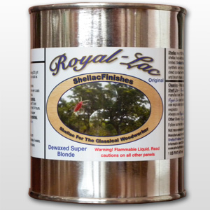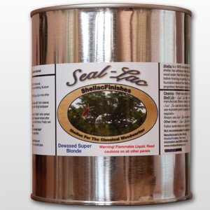

18) Work Sharp WS3000 - $249.95 - Donated by Worksharp/Darex/Drill Doctor
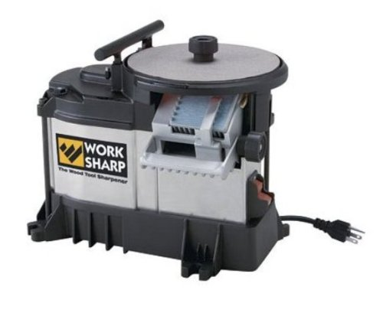
19,20) Qty=2 $25 Gift Certificates (2 separate prizes @ $25 each) - Donated by Craft Supplies (Woodturners Catalog)

21) TransTint Liquid Dye 12 Color Kit (2 oz bottles) - $180 or more - Donated by Homestead Finishing Products
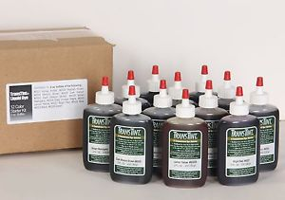
22) The Wood Whisperer Guild Bundle (Projects: Sofa Table, Barrister Bookcase, Grandfather Clock) - $255 - Donated by The Wood Whisperer

23) 1/2" Woodslicer Bandsaw Blade (any length in stock) - $30 - Donated by Highland Woodworking
24,25) Quick Cure 5 Epoxy ($18) and Barrel Bond Pen Turning Epoxy Gel Glue ($16) - $34 (2 prize bundles @ $34 each) - Donated by SystemThree
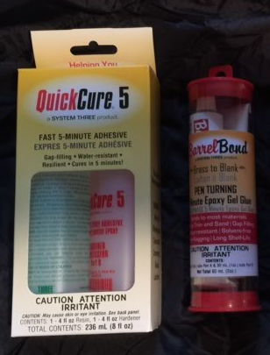
26) Laguna Proforce Bandsaw Blade, 1/2" width, 3TPI, 115" length - $29.99 - Donated by Klingspor's Woodworking Shop
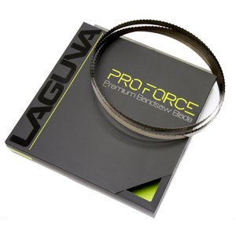
27) Laguna Shear Force Bandsaw Blade, 5/8" width, 115" length - $29.99 - Donated by Klingspor's Woodworking Shop
28) Work Sharp Knife & Tool Sharpener Ken Onion Edition ($129.95) & Replacement Belt Kit ($17.95) - $147.90 - Donated by Klingspor's Woodworking Shop
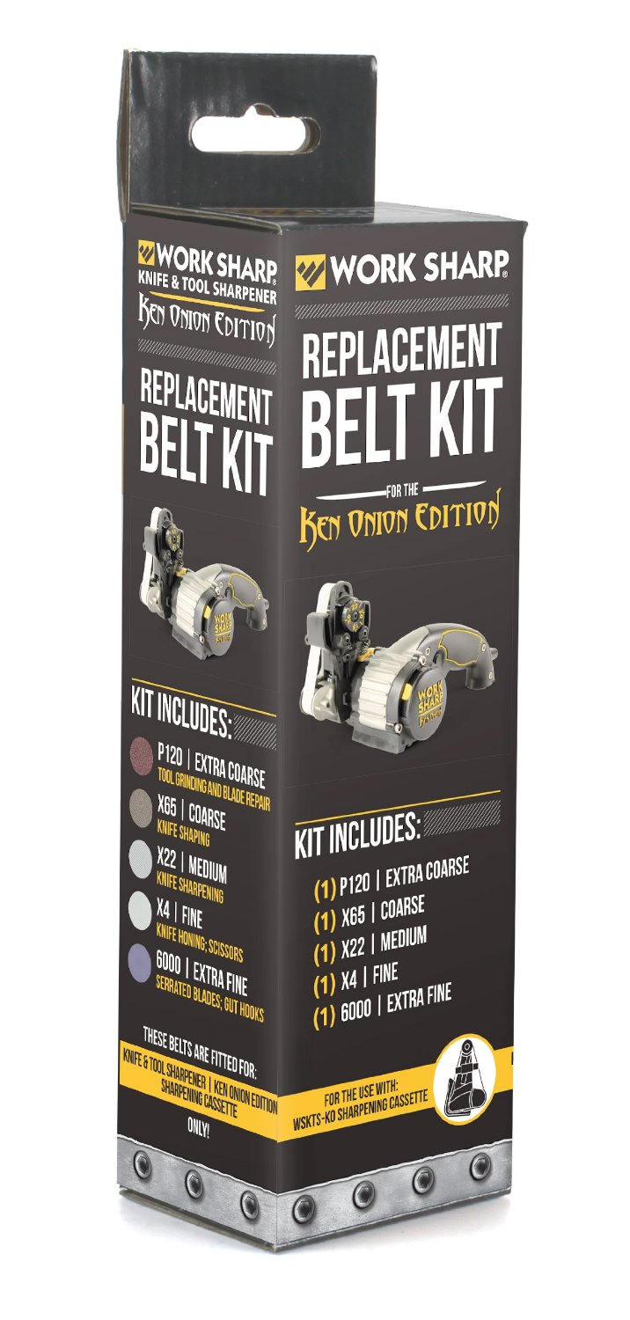
29) Work Sharp Upgrade Kit for the Guided Sharpening System - $34.95 - Donated by Klingspor's Woodworking Shop
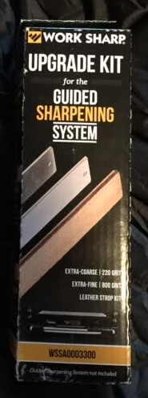

30) $1,000 Gift Certificate to Klingspor's Woodworking Shop - $1,000.00 - Donated by Klingspor's Woodworking Shop
31) Shop Bot 2-day On-Site CNC Training Class - $300 - Donated by Shop Bot Tools
2 Day On-Site CNC Training Class
32) CNC Bundle - $500 Gift Certificate to Inventables.com - Makers of X-CARVE CNC Machine ($500) & Shop Bot 2-day On-Site CNC Training Class ($300) - $800 Total Prize Value -
Donated by Inventables & Shop Bot Tools
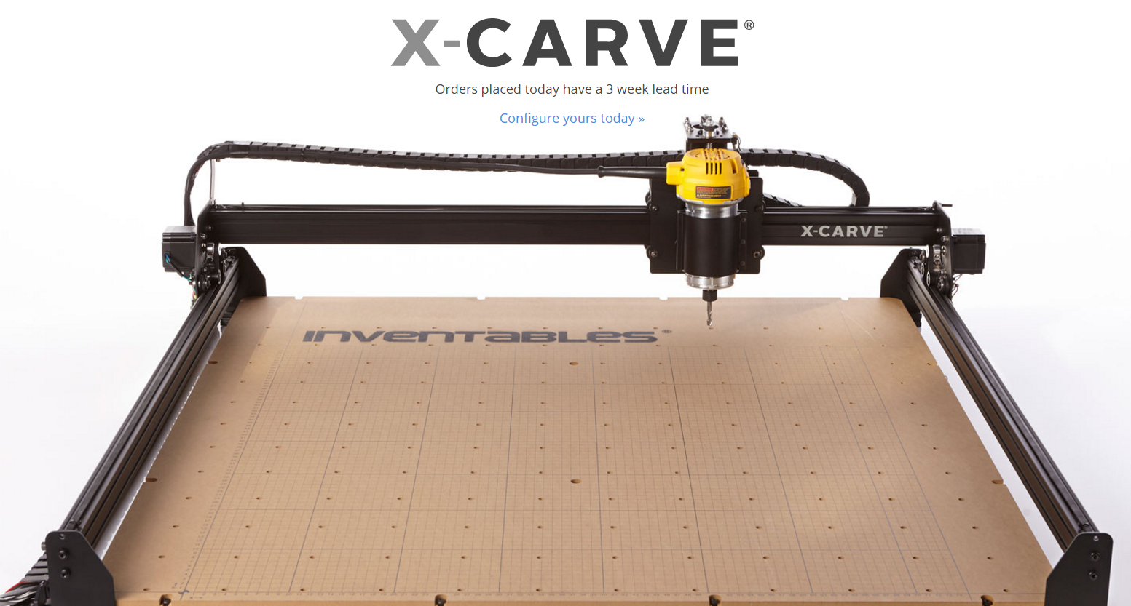
Note: Pictured X-Carve is not being given away. The $500 gift certificate can be used towards the pictured X-Carve.
2 Day On-Site CNC Training Class

33,34,35,36,37,38) Old Brown Glue Liquid Hide Glue, 20 oz bottle (6 Bottles @ $20 each) - Donated by Old Brown Glue
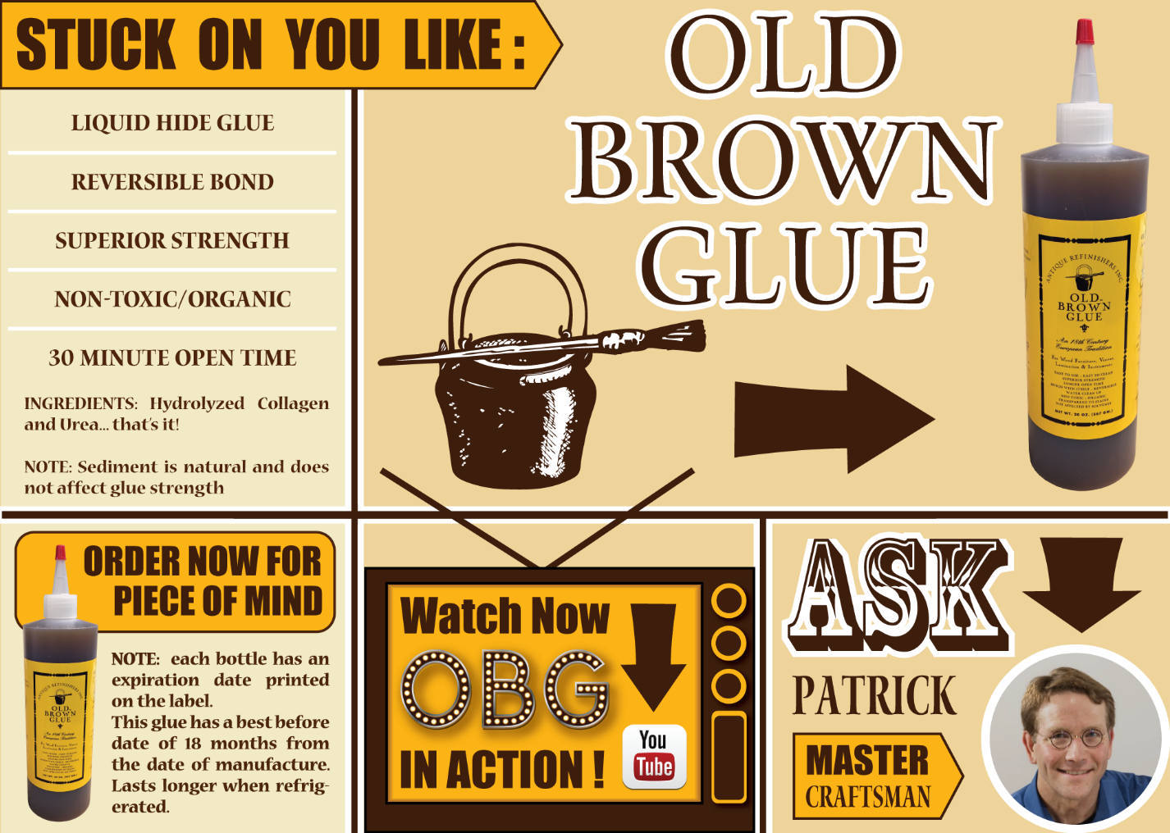
39) Festool Track Saw TS55 - $640 - Donated by Festool USA
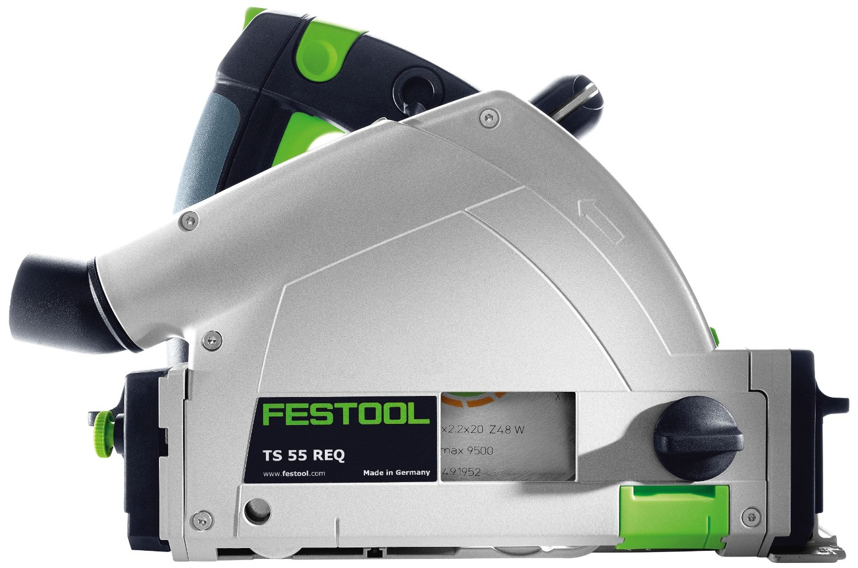
40,41) Drillnado Drill Press Dust Collection - (2 Prizes @ $39.90 each) - Donated by Drillnado
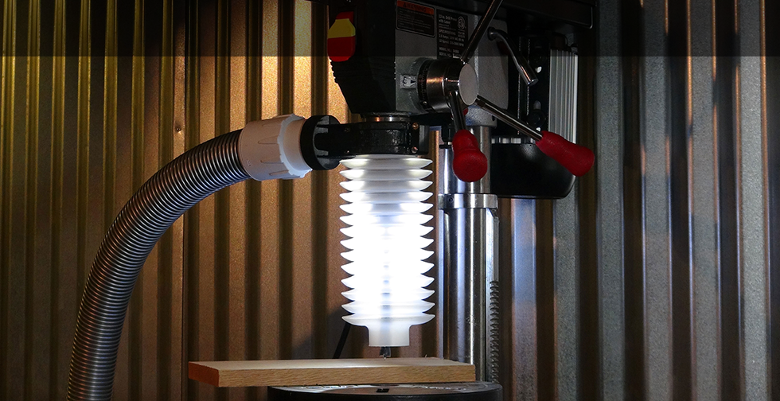
42,43,44) Qty=10 Assorted General Finishes Products - (3 Prize Bundles @ ~$170 each) - Donated by General Finishes
The three prize bundles will each have qty=10 products from the list of 30 below.
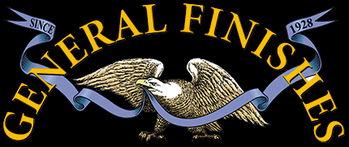
Pints: Water Based Dye Stain (4), Water Based Stain (3), High Performance Water Based Top Coat (1), Gel Stain (2)
Quarts: Enduro (3), Salad Bowl Finish (1), Arm-R-Seal Urethane Top Coat (3), Gel Stain (2), Exterior 450 Stain (3), Exterior 450 Top Coat (2), Gel Stain (2)
Other: Butcher Block Oil 16oz (2), Wood Turners Finish 8oz (2)
45,46) Qty=2 Kreg Tool K5 Master Systems - (2 Prizes @ $169.99 each) - Donated by Kreg Tools
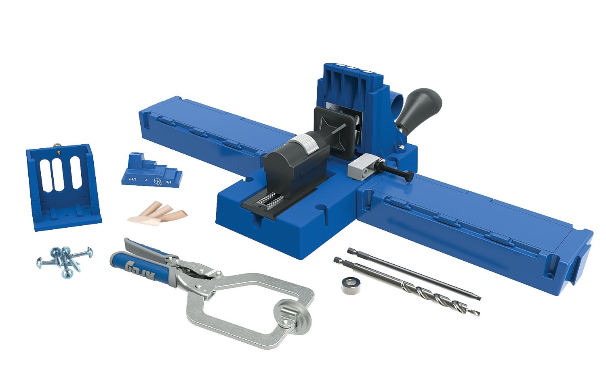
47) Hammer N3800 14" Bandsaw + Blades - $$2,700 Value - Donated by Felder USA
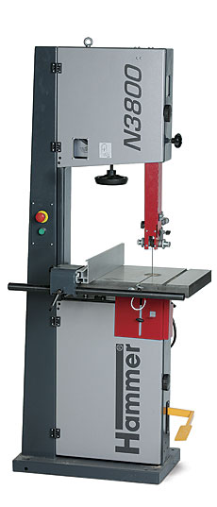
48) Blue Spruce 3/8" Dovetail Chisel - $95 - Donated by Blue Spruce Toolworks
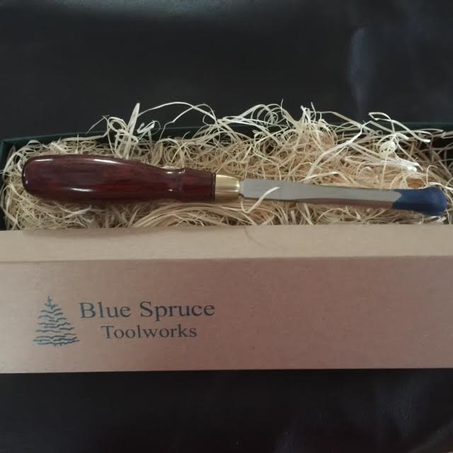

49) Tongue & Groove Hand Plane Set - $150 - Donated by Ed Lebetkin at The Tool Store at the Woodwright's School
50) Freud 91-104 6-Piece Router Bit Set - $207 - Donated by The Hardwood Store of NC
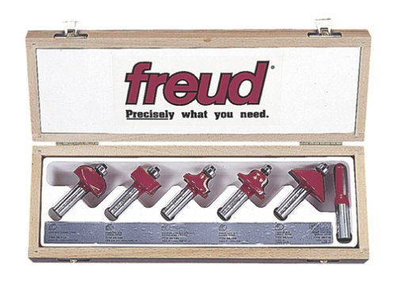
51) Veneer Bundle- $500 - Donated by Sauers & Company Veneers
