Figure Dust-collection Needs By The Numbers

Don’t guess on duct sizes and airflow. Easily calculate flow capacity, ductwork size, static pressure loss.
Is it finally time to tackle the dust problem in your shop? Don't gamble by guessing on duct sizes and airflow. These basic calculations will tell you what flow capacity you need, what size ductwork that calls for, and how much static pressure loss your dust collector must overcome to work effectively.

First, you’ll need to know the amount of air flowing in your system
Start by determining what the maximum airflow through the system will be. To do this, list the tools that you’ll connect to the system. Beside each one, jot down the dust-collection airflow it requires in cubic feet per minute (CFM). You can come up with this figure several ways:
- Look it up in the tool manual. (Not all manuals specify it.)
- Use the typical airflow values shown in Table 1. (Download and print a PDF with the tables and worksheets shown in this article.)

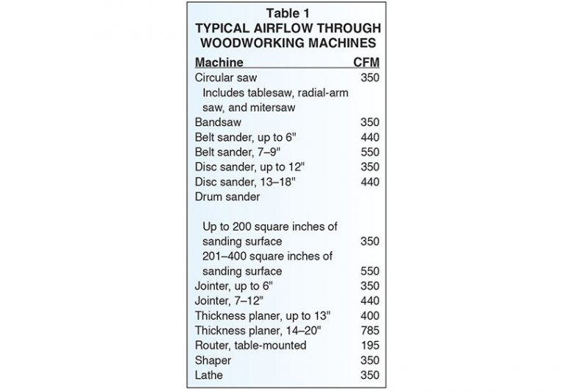

- Figure the flow based on the size (thus, the flow capacity) of the tool’s built-in dust-collection port. You can do this using one of these methods:
- For a round port, measure the diameter. Then, select the corresponding CFM value from Table 2, or
- For a rectangular port, calculate the area (multiply length times width, in inches). Then, multiply that area times 28 to find the approximate flow in CFM @ 4,000 feet per minute (FPM).

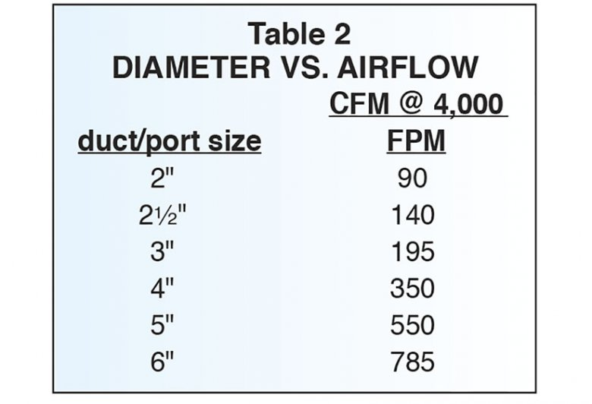

The single largest CFM figure on your list represents the maximum airflow your dust-collection system will have to support. (This assumes that airflow from each machine can be shut off with a blast gate. If you will have more than one machine operating at once or if a single blast gate serves more than one machine, add together the figures for those machines to find the maximum flow.)
Enter this CFM figure on Worksheet 1.

Next, find the diameter for your system’s main and branch ducts
The speed of air movement through a dust-collection system is critical. For systems carrying woodshop dust and chips, engineers recommend minimum air velocity of 4,000 FPM in branch lines (that’s about a 45 mph breeze) and 3,500 FPM in the main duct. The speed of the air moving in the system may exceed these figures, but shouldn’t fall below them. Maintaining the velocity at or above the minimum value ensures that dust and chips will remain in suspension as the air flows through the system.
Velocity of an airflow depends on duct size. Here’s how to find the right main duct diameter for your system:
- Find the value on Table 2 under CFM @ 4,000 FPM that’s nearest to—but less than—your system’s maximum flow, which is the CFM figure you entered on Worksheet 1. (We're using 4,000 FPM for main and branch ducts for simplicity.)
- Read to the left on the table to find the duct diameter that corresponds to that flow.
Say, for example, your largest airflow is 440 CFM for an 8" jointer. The nearest lower figure in the CFM @ 4,000 FPM column of the chart is 350, which indicates a 4" duct.
Resist the temptation to step up to a larger duct in hopes of improving flow. At the same flow, a larger duct will reduce air velocity, perhaps enough to diminish performance. For example, 440 CFM of air flows through a 4" duct at around 5,000 FPM. In a 5" pipe, velocity for the same flow is only 3,200 FPM—lower than recommended. If the velocity drops low enough, the result will be a system that won’t transport dust and chips at all.
Determine duct diameters for the system’s branch lines in the same way. Treat each one separately.

Determine the static pressure loss in the system’s ductwork
The final step in setting up your system is to calculate static pressure loss (SP loss). This figure represents the friction between the duct wall and air moving in the ductwork—friction that the blower must overcome to make air move through the system.
Figure each branch separately. Start by measuring the length of the branch duct in feet. Count the number of 90° and 45° bends in it. Where a branch enters the main duct through a 45° wye, count the wye as a 45° bend for the branch. Then, prepare a Duct SP Loss worksheet like Worksheet 2 shown below for each branch. Find values for the equivalent length of bends in Table 3.
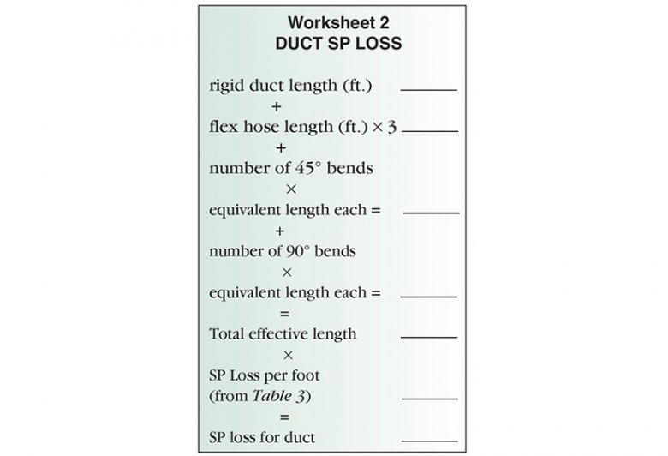

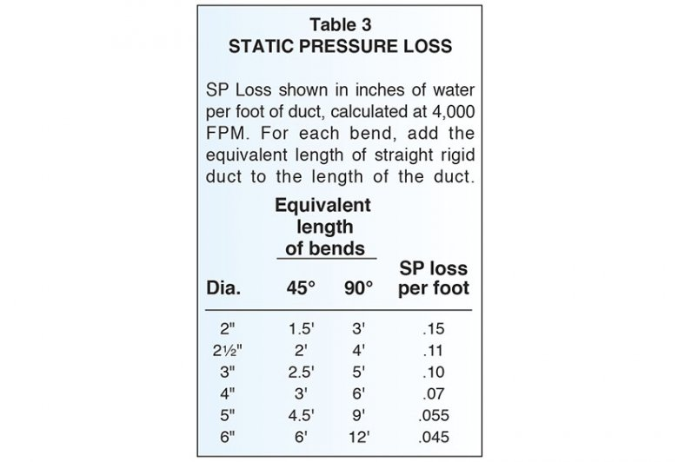
Now, taking each branch duct separately, figure the static pressure loss for the portion of the main duct that runs from the point where that branch enters it to the dust collector, using the Worksheet 2 format. Add this figure to the branch duct’s SP loss to find the total SP loss from the tool to the dust collector, and enter the values in Worksheet 3.
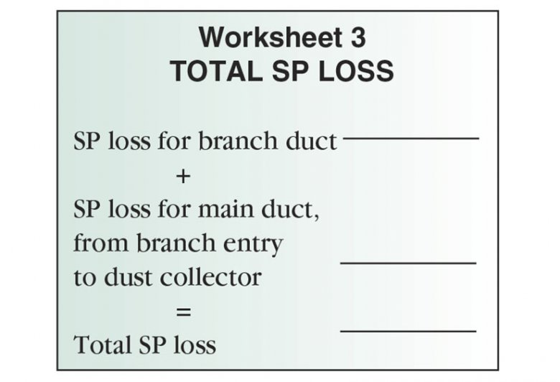
The largest value you calculate for your system then represents the static pressure loss your dust collector must be able to overcome. Enter this figure on Worksheet 1.
Worksheet 1 now shows the maximum CFM flow and static pressure loss for your system. To power your system, you’ll need a dust collector that meets or exceeds both figures.

